FiberPostProcess

Documentation

1 - NaN (Not a Number) values correction
Read all the data in a vtk/vtp file and verify that no values are set to NaN (not a number) or can create NaN values (due to zero tensors for example). If such a value is detected, it gives the possibility to remove all the fibers that have points with NaN values associated, or to add a field that specifies whether or not each fiber has points with NaN values associated.
FA computed and displayed along arc length
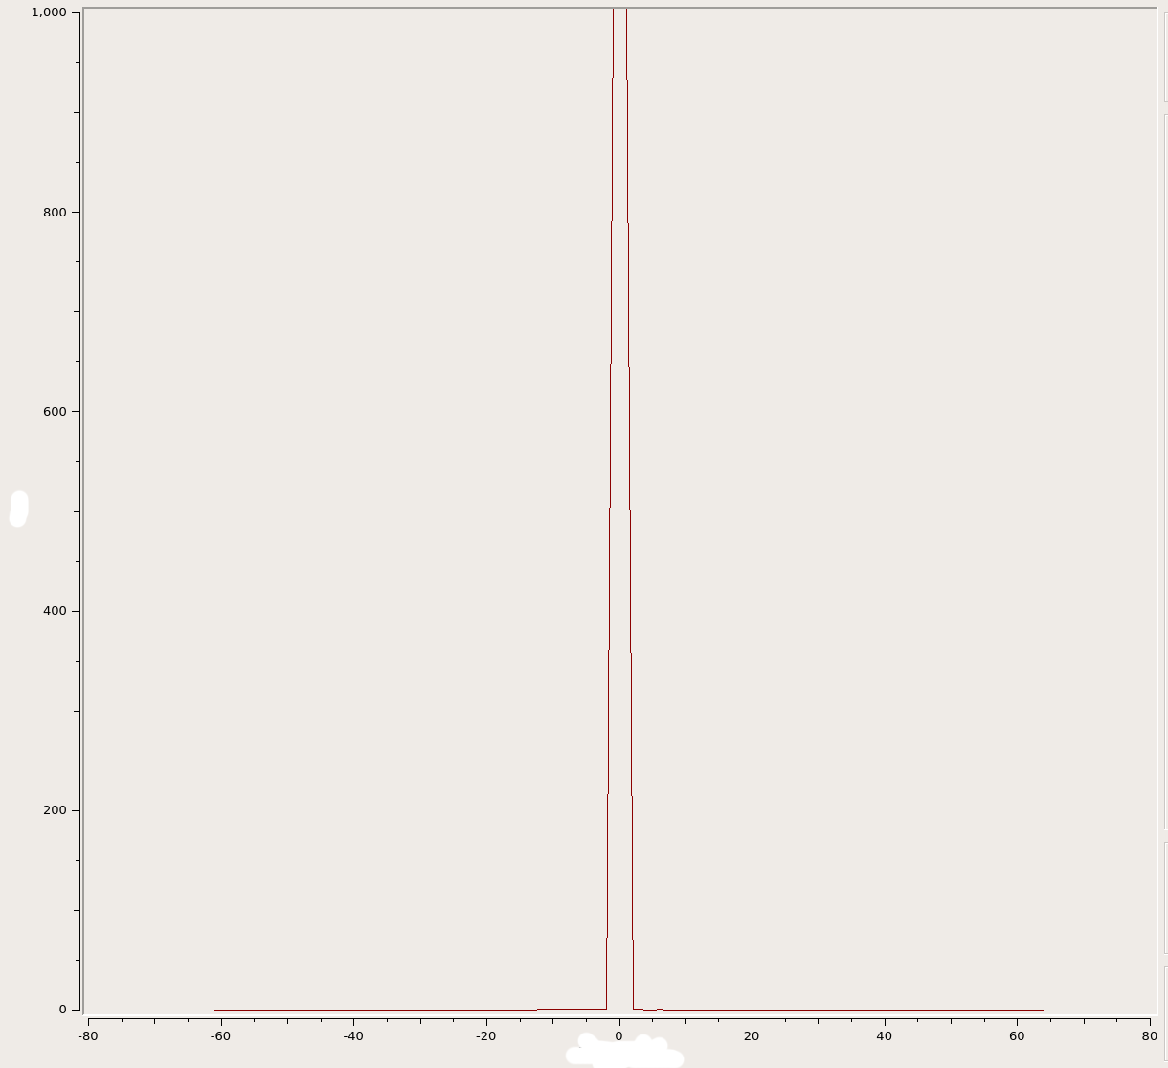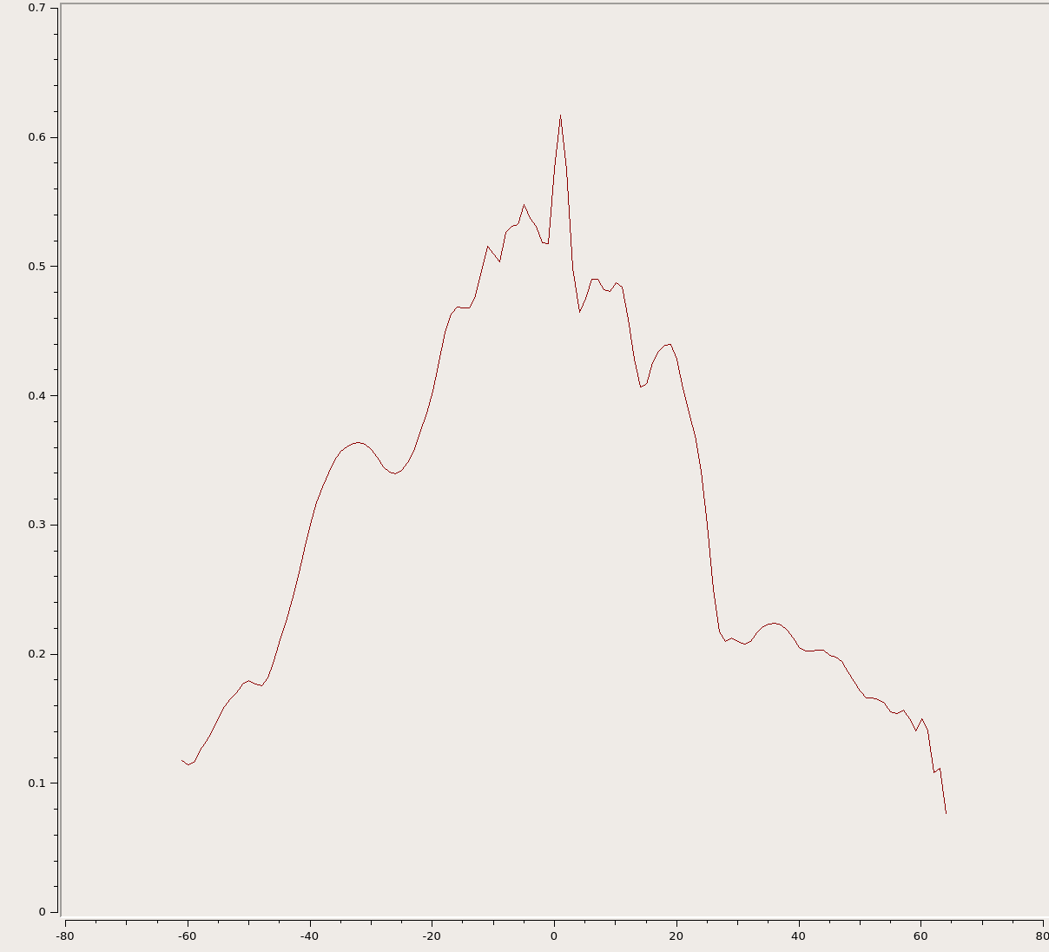
Left: non corrected NaN values, fa is not properly computed Right: corrected NaN values

2 - Fiber cropping

- to crop the tips of each fiber according to a mask. It can be an inclusion or an exclusion mask.

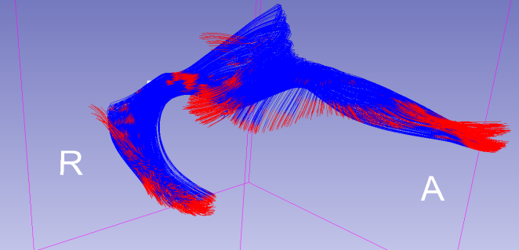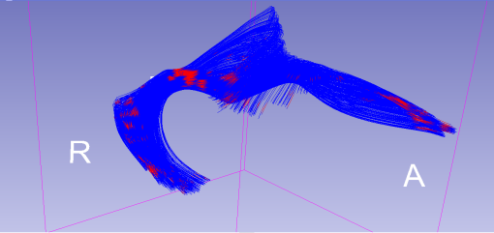
Left: non cropped fiber bundle (colors represent the masking of the bundle) Right: cropped fiber bundle

3 - Fiber masking
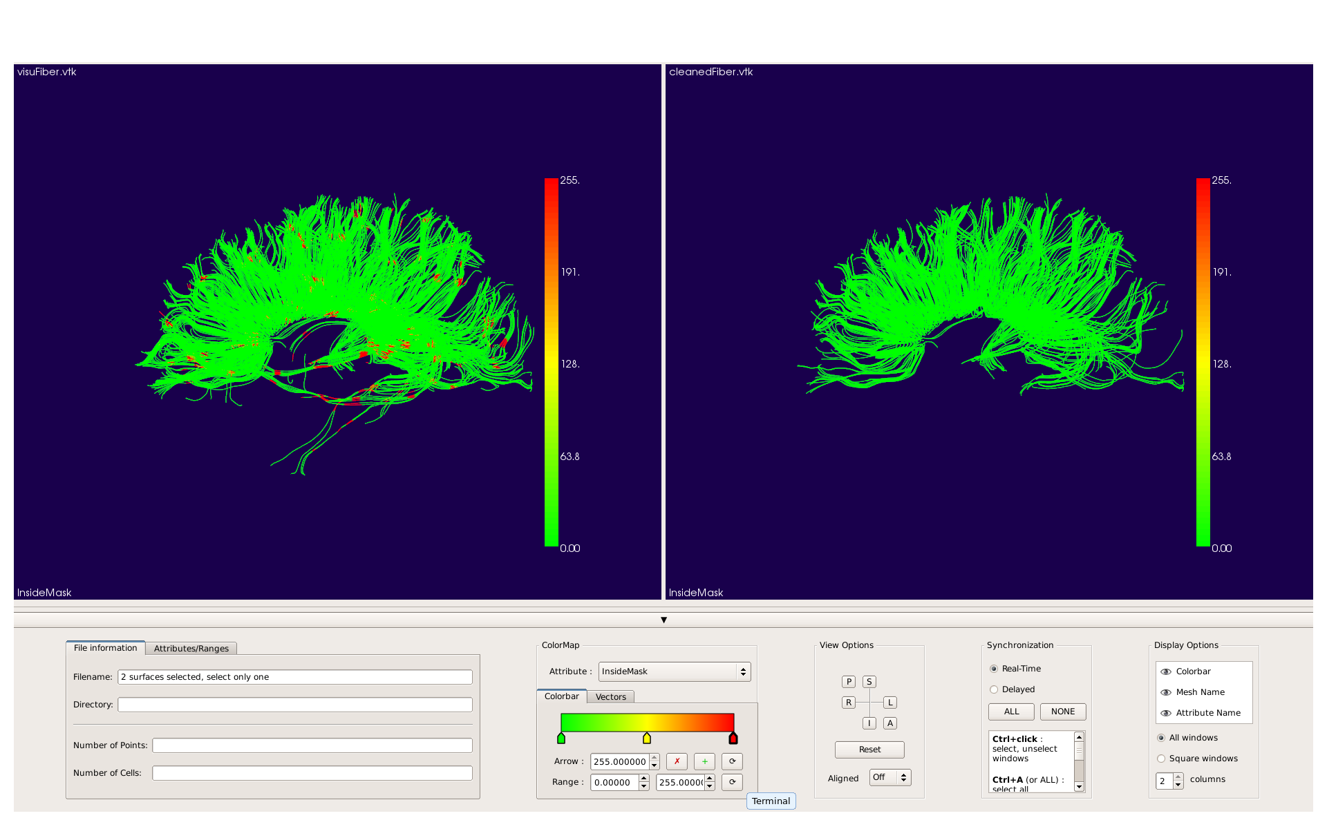
Left: non masked fiber bundle, colors represent the masking of the bundle
Right: masked fiber bundle, fibers containing too many (depending on the threshold set) red parts were removed

4 - Details on input parameters
Name of the input | Short flag | Long flag | Format accepted
inputFiberFileName | -i | --inputFiberFile | .vtk, .vtp
outputFiberFileName | -o | --outputFiberFile | .vtk, .vtp
attributeFileName | -m | --attributeFile | .nrrd, .nhdr, etc
thresholdMode | n/a | --thresholdMode | "below" or "above"
threshold | -t | --threshold | float
mask | n/a | --mask | binary
crop | n/a | --crop | binary
clean | n/a | --clean | binary
noNan | n/a | --noNan | binary
visualisationFlag | n/a | --visualize | binary

- inputFiberFileName: name of the fiber file that will be processed.
- outputFiberFileName: name to be given to the output fiber file.
-attributeFileName: name of the attribute file (can be a binary mask file) that will be used to mask or crop the input fiber file.
-thresholdMode: can be set to "below" or "above" , determines if the mask will include what is above (if set at above) or what is below (if set at below) the threshold. Each fiber will have a cell data called "removeFiber". It is set to 1 if the fiber is considered to be removed, 0 otherwise.
- threshold: value of the threshold (float), given between 0 and 1.
- mask: if toggled the mask given by the attribute file will be applied to the input fiber file. Cell datas will be added but fibers will not be removed (clean flag need to be toggled too).
Need: inputFiberFileName, outputFiberFileName, attributeFileName to be given.
- crop: if toggled, the input fiber file will be cropped. It is getting cropped depending on the attribute file given.
Need: inputFiberFileName, outputFiberFileName, attributeFileName to be given.
- clean: if toggled, fibers considered outside (or inside, depending on the threshold mode) will be removed in the output fiber file.
Need: inputFiberFileName, outputFiberFileName, attributeFileName to be given and mask flag toggled.
- noNan: if toggled, fibers containing Nan values will be removed in the output fiber file.
Need: inputFiberFileName, outputFiberFileName to be given.
- visualizationFlag: if toggled, a second output file is created. This file will be accepted through Slicer or any other tool that can read vtk file, and contains all data fields created during the process.

